march 1, 2023 – August 2, 2023  Bright stars primary learning academy  GA PreK 2023-2024 Enrollment  We are currently accepting applications for our 2023-2024 Georgia Funding Lottery PreK. If your child will be turning 4 years old on or before September 1, 2023, then he or she is eligible for enrollment. If you want to enroll your scholar, then please retrieve an application from our website brightstarsprimarylearningacdemy.com or visit Bright Stars Primary Learning Academy located at 8733 Tara Blvd., Jonesboro, GA 30236  All PreK students are required to wear uniform (red or blue) polo shirts with our school logo. You can purchase shirts at Bright Stars Primary Learning Academy  We will be providing FREE before/aftercare from 2:30pm – 4:00pm  For additional information contact:  Mrs. Jasmin, Director  Ms. Courtney, Assistant Director  770-892-0160  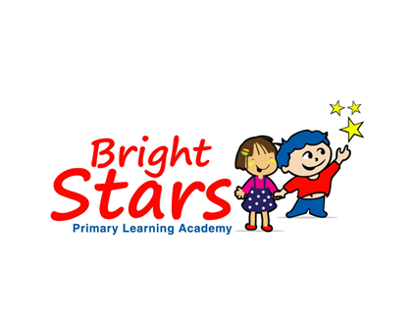 | Must complete an Enrollment Packet  Provide Parent’s ID and Social Security Card  Documents Required:  Child’s Birth Certificate  Proof of Residence  TANF, Medicaid, CAPS, Food Stamp Card (if applicable)  Child’s Social Security Card  Certificate of Immunization  Form 3300  Orientation:  Saturday, July 29, 2023  12p to 2pm

